Geography
Religious Education- How do we know New Babies are Special?
By the end of this unit children will know...

Vocabulary

Year 1 Summer 1 - On Safari

- Some people believe that humans have a special relationship with God.
- Many people have special ceremonies when babies are born.
- Some spoken and written words are important to people.
- Some religious and non-religious people carry out ceremonies when babies are born to welcome them into their community.
- Religious baby welcoming ceremonies often include symbols and actions to show the baby’s relationship with God.

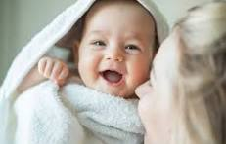

Children will build on their previous knowledge from when they learnt about growing up in Reception. They have also discussed new babies when children in the class have had a new brother or sister. In R.E the children have looked at celebrations.
Allah, belief, believe, blessing, Brahman, ceremony, community, Christian, creation, God, Hindu, Humanist, Jewish, Muslim,
Religion, Sikh, Trimurti, Worldview

Intention

In this unit we will be finding out about different ceremonies to welcome home a new baby and exploring some of the symbolism in these ceremonies.

How do we know New Babies are Special?- Previous Learning

Learning Links
This Summer 1 R.E unit, How do we know new babies are special? builds upon children’s earlier experiences from Year 1 Kapow R.E, such as learning about special people, special places, and why certain moments or rituals matter to different communities. Children have already explored ideas like caring for others, belonging to groups, and why families celebrate important events—all of which provide a foundation for understanding how different religions welcome new babies.
The unit strengthens childrens’ understanding of key concepts from the National Curriculum for RE, including recalling different beliefs and practices, recognising symbols and actions used within religious communities, and asking and responding to questions about identity and belonging. By exploring Muslim practices such as Adhan and Aqiqah, Hindu beliefs through Jatakarma, and Christian baptism promises, pupils revisit and extend their knowledge of God, creation and community introduced earlier in Year 1. The content also deepens their awareness that both religious and non-religious families celebrate new life in meaningful ways.
Through comparing ceremonies, pupils build on their prior understanding of celebrations e.g., Diwali, Christmas and Eid and continue developing the skills of identifying similarities and differences between different worldviews. This unit supports children to make thoughtful connections between beliefs, actions and symbols; to recognise why families choose to celebrate new babies; and to express their own ideas about belonging and what makes people special.

Religious Education- How do we know that Babies are Special?
We will be finding out about different ceremonies to welcome home a new baby and exploring some of the symbolism in these ceremonies.
Knowledge Progression Across the Unit:  Lesson 1- Exploring the belief in a God created humans.  Lesson 2- Explaining that Muslim people welcome a new baby with the Adhan  Lesson 3- Investigating how some Muslim people welcome a new baby by Aqiqah.  Lesson 4- Explaining how some Hindu people welcome a new baby by exploring Jatakarma.  Lesson 5- Exploring how promises are made during Christian baptism ceremonies.  Lesson 6- Identifying why names are sometimes an important part of baby welcoming ceremonies.  Key Objectives-  To suggest reasons why people might celebrate a new baby.  To identify reasons why some Muslim people welcome a new baby with Adhan.  To recognise the key parts of Aqiqah and why these are important to some Muslim people.  To identify the important parts of Jatakarma and why these are important to some Hindu people.  To explore similarities between Jatakarma, Adhan and Aqiqah.  To identify what a promise means in a Christian baptism.  To explain ways in which some people choose a name for a new baby.  To describe what happens at religious and Humanist baby naming ceremonies. | Lesson 1- How do we know that babies are special?  Foundational Skills: Listening and attention skills are developed when children recap beliefs and discuss why babies are special.  Expressive language is used as children describe images and choose words for their new-baby cards.  Fine motor control is used when making and decorating their cards.  Understanding of people and communities grows through exploring why families celebrate new babies.  Learning Objective: To explore the belief in a God that created humans and suggest why babies are special to parents.  Success Criteria: I can recall the belief that there is a God who made humans in the creation story. I can discuss why new babies are considered special. I can suggest why birth is celebrated.  Recap and Recall Show the children images linked to the Jewish and Christian creation story and ask: “What do some people believe about how humans were created?” This revisits their earlier learning that some people believe God created humans. Then ask: “Why might new babies be special?” to check their initial ideas before new teaching.  Recap previous learning by discussing the following:  Some people believe in a God who created the world and everything in it.  Creation stories explain how the world began.  Some people believe caring for the world and all living creatures is important.  Starter:  Hand out a selection of religious and non-religious new baby cards on each table if possible.  Display the images on the Presentation: New baby cards and ask the children to discuss in pairs:  What do the pictures show? (New baby cards.)  When do people usually give someone a new baby card? (The children may suggest when someone has a new baby or at a special ceremony such as a baptism.)  What words would you use to describe new babies? (Various suggestions may include special, cute, precious, beautiful or tiny.)  Main: Display quote-  'God made the first man from dust on the ground. He breathed life into the man's nose and then the man started to breathe and was alive.' Genesis 2:7  What does this tell us about what some people believe God can do?  What does this tell us about what some people believe God can do?  Show the following picture-  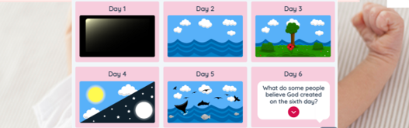  Which story are these pictures from? (The Jewish and Christian creation story.)  What happened next? (On the sixth day, God created humans.)  Show the following slide-  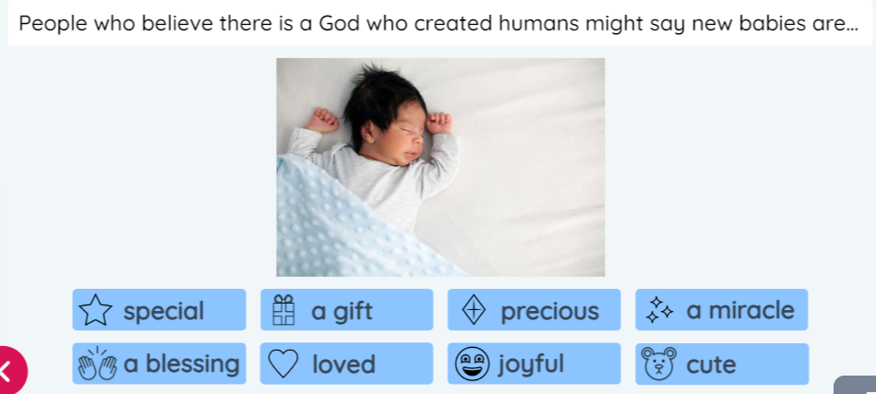  Discuss the meaning of words. What other words could we add?  Discuss- How would you finish the sentence?  ‘People who believe there is a God who created humans might say new babies are…’  Ask the children- Is it only people who believe in God who think new babies are special? (The children may suggest: No, everyone can think new babies are special.)  What other reasons might people have for thinking new babies are special? (Various suggestions may include: babies are part of a family and they can make people smile and feel happy; babies are like a new beginning and they might grow up to make the world a better place.)  Activity:  Children to make their own new baby card from somebody who believes in God.  What symbols will you make sure are on your card?  What special messages?  Provide the children with pre-cut images for their cards.  Take photos for Seesaw. Discuss- Why do people send baby cards. Record for Seesaw and add QR code to books.  Plenary:  Invite the children to share their new baby cards.  Explain that during the week, there will be resources for them to role-play all of their learning about new babies. | Lesson 2- What do some Muslim people do to show a new baby is special?  Foundational Skills: Listening and attention skills are strengthened while children listen to the Adhan.  Expressive language skills are used when explaining why the Adhan is whispered and who says it.  Vocabulary development occurs when children use word cards and choose a key word to describe their learning.  Understanding of different communities develops through learning how Muslim families welcome new babies.  Learning Objective: To explain why some Muslim people welcome a new baby with the Adhan.  Success Criteria: I can describe what the Adhan is. I can identify who says the Adhan to a new baby. I can discuss why some people believe introducing a new baby to God is important.  Recap and Recall Ask children to recall last lesson’s key idea: “Why do some people believe new babies are special?” Then show a picture of a family with a new baby and ask: “What did we learn about how people welcome babies?”  Ask the children which words they think go together?  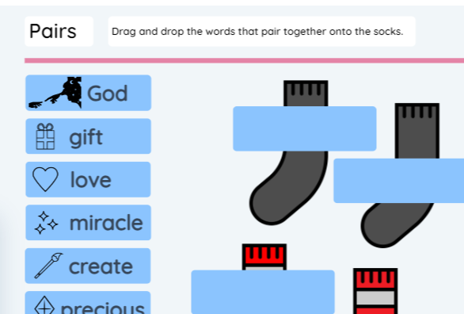  Starter:  Display- 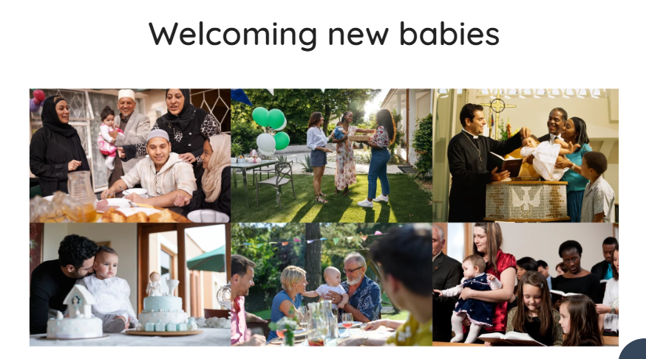  Who is in the picture?  What are they doing?  How can we tell they care for/love the baby?  How can we tell this is a special occasion?  Discuss with the children if they can remember welcoming a new baby.  Main: What do Muslim people believe about God?  Explain that Muslim people believe that God created the world and everything in it, including us.  Activity:  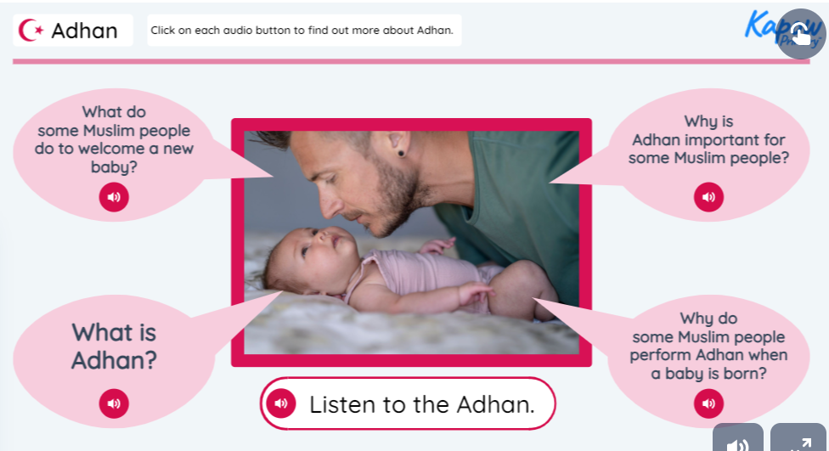  Listen to the audio clips.  Why do you think the Adhan (call to prayer) is whispered into the baby’s ear? (The children may suggest that it is the first thing the baby should hear, to introduce the baby to believing in God.)  Why is the parent saying words about God to the baby at such a young age? (The children may suggest they want the baby to know about God as soon as they are born; asking God to take care of the new baby.)  Why do you think the baby’s father whispers this prayer? (The children may suggest the father is showing he will take care of the baby and teach them about their religion because the baby is too young to pray.)  Hand out the Activity: Adhan word cards (one between two). Explain that they will listen to all of the audio again but this time, they need to work in pairs to hold up the words as they hear them.  *Photograph/record for SeeSaw.. Add QR codes to books.  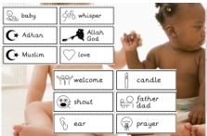  Plenary:  Ask the children to select one word from the Activity: Adhan word cards that will help them remember what they learned from today the most.  Allow the children to select a card and ask them to walk around the room and find other children who have chosen the same words to form a group with.  Give them two minutes to find as many other children as they can. Choose volunteers to share which word they chose and why.  Add any new words to the word wall and invite the children to add their own words on the blank cards using the Activity: Adhan word cards.  Questions  Did the children in your group choose the word for the same reason as you?  Which words should we add to the word wall?  Are there any words on the word wall that link to our learning today?  Ask- What is Adhan?  HA- to write sentence to answer.  Other children to answer verbally. Record children’s ideas for Seesaw and print QR codes for books.  Watch- The Adhan (spoken) | Call to Prayer | Channel 4 (youtube.com) | Lesson 3- What is Aqiqah and why is it important to some Muslims?  Foundational Skills: Listening and attention skills are needed when following the Aqiqah presentation.  Expressive language is used as pupils explain the meaning of charity and discuss the ceremony.  Early reading and vocabulary skills are applied when matching words and pictures.  Understanding of people and communities deepens through learning about generosity and celebration.  Learning Objective: To explain how some Muslim people welcome a new baby by investigating Aqiqah.  Success Criteria: I can explain why some Muslim people shave a baby’s head.  I can describe the meaning of charity and why this is important to some people.  Recap and Recall Ask the children to tell their partner everything they remember from last week about the Adhan: who says it, why it is whispered, and what it means. Then ask: “How did Muslim families show love and welcome to the new baby?” to reinforce prior knowledge before introducing Aqiqah.  Starter: Show the children the following picture.  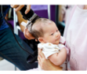  Ask- Who is in the picture? What is happening?  Main: Display the Aqiqah presentation.  Click on each picture to hear the explanation about what happens during Aqiqah.  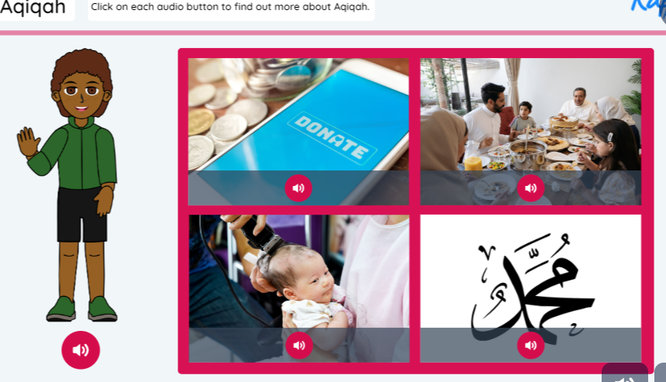  Why might people give to charity at Aqiqah? (The children may suggest looking after other people who might not have as much or giving thanks.)  Point out that many people may have special rules and guidance to live a respectful and caring life. Explain that this guidance is called the Five Pillars of Islam for Muslims. One of the five pillars of Islam is Zakat (charity – helping others by giving them what they need).  Explain that community means a group of people who live in the same area or share common interests, beliefs or activities.  Questions:  Can you think of any rules that have helped you to live a respectful or caring life? (The children may suggest school rules.)  How is this like some school rules? (The children may suggest both Zakat and our school rules want us to be kind and help people.)  Plenary:  Explain that each table has a picture on that is connected to Aqiqah.  Match word cards the to a picture.  Take photos/video for Seesaw.  Which picture do you think is the most important in Aqiqah and why?  Can you think of any connections (links) between the pictures? (The children may suggest the pictures show a baby’s family welcoming them; the father whispers special words into the baby’s ear; the baby’s family celebrates the new baby with a special meal.)  If each picture had a title, what do you think they would be?  Record children’s ideas for Seesaw and print QR code.  Watch Aqiqah for Boys and Girls (youtube.com).  .
Lesson 4 - What is Jatakarma and why is it important to some Hindu people?  Foundational Skills: Listening and attention skills are applied during sound clips and discussion of creation stories.  Expressive language is used as children explain what happens in Jatakarma.  Fine motor control is developed when drawing a picture linked to their chosen word.  Understanding of communities and differences grows through comparing Jatakarma with Muslim ceremonies.  Learning Objective: To explain how some Hindu people welcome a new baby by exploring Jatakarma.  Success Criteria: I can identify the important parts of Jatakarma. I can describe why Jatakarama is important to some Hindu people. I can explore similarities between Jatakarma and Adhan and Aqiqah.  Recap and Recall: Display five words linked to previous learning (e.g., God, whisper, charity, family, celebration) and ask children to recall how they connect to Adhan and Aqiqah. Then ask: “What do Muslim families do to welcome a new baby?” to refresh understanding before comparing with Hindu practice  Display the Presentation: Gimme five! Ask the children to recall five words connected to their learning about Adhan and Aqiqah.  When a new baby is born, some Muslim people whisper Adhan into the baby’s ear to introduce the baby to God.  Some Muslims celebrate a new baby with Aqiqah, where they might buy food from a special butcher and give some to charity.  At Aqiqah, the baby’s head is shaved and the hair is weighed. The same amount of money is given to charity.  The family sometimes has a big meal and brings gifts for the new baby.  The new baby’s name is sometimes announced, and the family says a special prayer.  Starter: Display the following image-  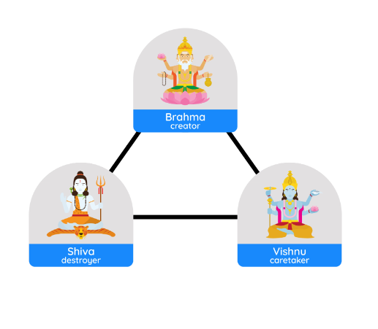  Remind the children that many Hindu people believe in one God – Brahman. Recap that the Trimurti represents three forms of God with distinct roles.  Questions:  - What are the names of the three forms of Brahman? (Brahma, Vishnu and Shiva.)  - Which role is connected to learning about why new babies are special? (Brahma – the creator.)  Watch- Hindu creation story... - VideoLink  What did you see? (The children may suggest that while Lord Vishnu slept, a sound started.)  What did you hear? (The Aum sound growing louder and louder.)  How did the sound make you feel? (Various suggestions may include peaceful, calm or relaxed.)  Explain that the Aum symbol and sound represent the three forms of God. Play the rest of the video.  Main: Listen to the following sound clips-  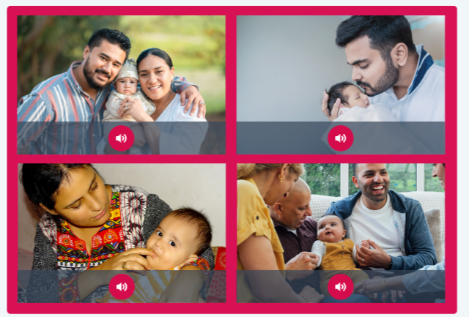  Which parts of Jatakarma introduce the baby to God? (The children may suggest the baby’s father whispering Brahman into their ear; writing Aum on the baby’s tongue.)  Why do you think honey was sometimes given to the baby? (The children may suggest because it is sweet; to wish the baby a sweet life.)  How is Jatakarma similar to the Muslim ceremony of Adhan and Aqiqah? (The children may suggest the baby’s father whispering special words into their ear.)  Activity:  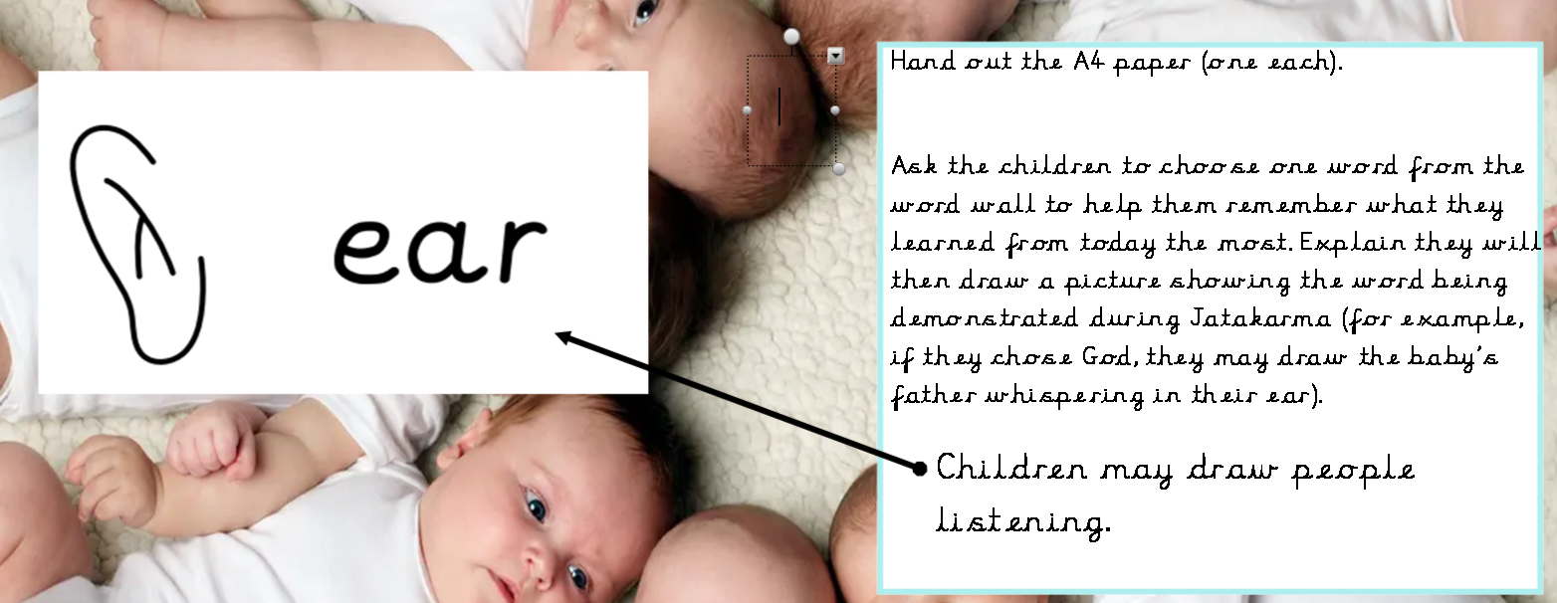  Ask the children to choose one word from the word wall to help them remember what they learned from today the most. Explain they will then draw a picture showing the word being demonstrated during Jatakarma (for example, if they chose God, they may draw the baby’s father whispering in their ear).  HA- Write why have you chosen this word.  Plenary: Invite the children to share their pictures with their partners and see if they can guess which word they chose.  Ask the children to discuss in pairs:  Are the reasons why some Hindu people welcome a new baby with Jatakarma similar to why some Muslim people welcome a new baby with Adhan and Aqiqah? (The children may suggest they are similar because the baby’s father whispers special words in the baby’s ear in both Adhan and Jatakarma; both are about showing love and saying ‘welcome’ to the new baby; the family does special things to show the baby is important and to introduce them to God and their community.) | Lesson 5- What promises might people make for a baby?  Foundational Skills: Listening and attention skills are used when exploring baptism images and promises.  Expressive language develops as children describe symbols and explain the meaning of a promise.  Vocabulary knowledge grows through identifying and linking words from the presentation.  Understanding of people and communities is strengthened through comparing baptism with other ceremonies.  Learning Objective: To explore how promises are made during Christian baptism ceremonies.  Success Criteria: I can describe what a promise is. I can discuss what promises might be made by some Christians for a new baby. I can make links between baby welcoming ceremonies.  Recap and Recall: Ask children to tell a partner something they learned about Adhan, Aqiqah, and Jatakarma. Then ask: “What do these ceremonies have in common?” This revisits similarities between welcoming ceremonies before learning about Christian baptism.  Tell your friend anything you have learnt about baby welcoming ceremonies so far.  Tell your friend two things your found interesting about baby welcoming ceremonies.  Tell your friend one question you still have. Note down questions on flip chart paper.  Starter:  Display the ‘Promises’ presentation.  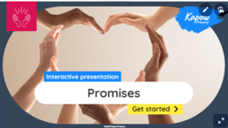  Discuss- What is a promise? (A promise is when you say you will do something and then do it.)  Can you think of any promises you have made or might make? (The children may suggest promising to tidy up their toys and then doing it.)  Discuss that a parent, family or friend might make a promise for a new baby.  Main:  Display slide 1 of the Presentation: Baptism.  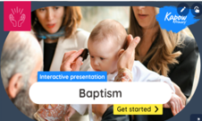  Ask the children to discuss in pairs:  Who is in the pictures? (The children may suggest a baby, the parents, family, a priest, vicar or pastor.)  What objects can you see? (A Bible, a candle and a font – a special bowl that holds water for baptising babies.)  What symbols or signs of God can you see? (A cross, a candle and an image of Jesus.)  What do you think is happening in the pictures? (The children may suggest the priest is reading a prayer to the baby; the family are making a promise for the baby; the family are in a church to celebrate the new baby; water is being poured on the baby.)  Point out that godparents are special people sometimes chosen by Christian people to help look after and teach the child good things as they grow.  Questions  Why do you think they are called godparents? (The children may suggest they help teach the baby about God and take care of them in a special way as parents do.)  Show slide 2 and read the example of a promise usually made by parents and godparents at the Christian baptism. Ask the children which words in the example of a promise said at a baptism they think are the most important and why. (The children may suggest God, church, prayer, Jesus and community.  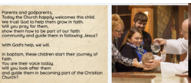  Questions  What are the parents and godparents promising? (The parents and godparents promise to look after the baby, guide them, pray for them and show them how to be part of the Christian Church.)  Why do the baby’s parents make the promise for the baby? (The children may suggest because the baby is not old enough to do this for themselves.)  What do you think is important to the new baby’s family and friends? (The children may suggest that some people make a promise to thank God for the baby, which is important; family/community is important for some people when they welcome a baby.)  Are there any similarities between a Christian baptism and other baby welcoming ceremonies? (The children may suggest the father making a promise for the baby is similar to Adhan and Jatakarma when the father whispers the special words into the baby’s ear because the baby cannot do this for themselves; they are all about the baby being special/connected to God.)  Activity:  Display the following presentation:  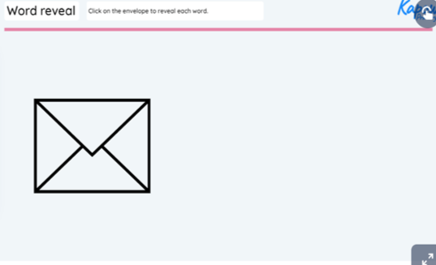  Tell the children that as we reveal the words they need to walk with your partner to decide if the word is connected to Baptism or not. If it is ask the children to add it to their paper.  Which word will help you to remember your learning the most?  Plenary:  Ask the children to work in pairs to match any words they think are connected.  Add any new words to the word wall.  Questions  Which words are connected? (The children may suggest godparents, parents and promise are connected because they make a promise for the baby; love and community are connected because they promise to make the baby part of the faith community.)  Are there any words that were not linked to today’s learning that are connected? (The children might make links with Adhan, father and whisper.)  What could you add to the role play resources for during the week? (The children may suggest a Bible, a candle or water.)  Complete KWL grid to show what the children have learnt this half term. | Lesson 6: How are some babies named?  Foundational Skills:  Listening and attention skills are developed when children discuss how some babies are named. Expressive language is used as children describe ways in which babies are named. Fine motor control  Understanding of people and communities grows through exploring why families celebrate new babies.  Learning Objective: To identify why names are sometimes an important part of baby welcoming ceremonies.  Success Criteria: I can identify the ways some people choose a name for a baby.  I can describe what some people might do at baby naming ceremonies.  I can look for similarities between religious and Humanist baby naming ceremonies.  Recap and Recall: Arrange the children in pairs. Hand out the Resource: Knowledge organiser: How do we know that new babies are special? to each pair. Display the Presentation: Using the Knowledge organiser. Read the slide together, then allow time for the children to complete the activity.  Take feedback, asking pairs to share what they remembered.  Starter:  Display slide 1 of the Presentation: Baby naming ceremonies. Click the Torah or Bible to read the quote. ‘God made all animals and birds and let Adam name them.’ Genesis 2:1 sk the children to discuss in pairs:  Can you think of a time when you chose a name for a pet or a toy?  How do people choose a name? (Answers may include: sometimes a name is chosen because it has a special meaning.)  Point out that naming a pet or a toy is an example of ownership (who something belongs to).  Display slide 2 and click on each person to read how people from different worldviews choose a name for a new baby.  Ask the following questions:  Why might some people choose to have a special event or ceremony where a baby or child is given their name, often with family and friends? (To introduce the baby to family and friends.)  How do some people choose a name for a new baby? (Some Muslims choose a name with a special meaning; some Jewish people choose the name of a family member who is no longer here so that they can remember them; some Sikh people open a special book, ​​Guru Granth Sahib, and use the first letter on the page to choose a name.)  Main:  Remind the children that people who follow a Hindu worldview generally believe in one God (Brahman) who can take on many forms.  Play the Pupil video: Namakarana.  Ask the children:  What helps to choose the baby’s name in the Namakarana ceremony? (The baby’s name is chosen using the date and time they were born.)  Why is the baby’s name important in the Namakarana ceremony? (Answers may include: the name is special because the parents believe it can help the baby have a good life.)  Who whispers the baby’s name in the Namakarana ceremony? How is this similar to other baby welcoming ceremonies? (The baby’s father whispers the name, similar to the Adhan and Jatakarma when the baby’s father whispers special words into the baby’s ear.)  What would you include in a baby naming ceremony that is not connected to belief in God? (Answers may include: telling everyone the baby’s name and why it was chosen; bringing a gift for the baby; singing songs; sharing a special meal; playing games.)  Remind the children that people who follow a Humanist worldview generally believe there is not a god or gods and that people should live for the good of all humans.  Play the Pupil video: Humanist baby naming ceremonies.  Ask the children:  Who might be invited to a baby naming ceremony when it is not connected to a belief in God? (Similar to a religious ceremony, friends and family are important.)  Where might they be held? (Answers may include: they can be held anywhere; the parents can decide.)  Provide the children with the Activity: Venn diagram and the Activity: Images to sort (pre-cut, one between two). Ask the children to look at each image and decide if it describes a baby naming ceremony connected to belief in God, not connected, or both.  Model how to sort an image on the Venn diagram in the appropriate section using slide 1 of the Presentation: Exploring baby naming ceremonies. Show the children two examples before asking them to complete the activity. Slide 2 can be used as an extension.  Which action do you think is most important?  Can you think of anything else people might do to welcome a baby?  Plenary:  Ask the children to discuss in pairs:  How do we know that new babies are special? (Answers may include: families have special ceremonies to welcome them, e.g. Adhan and Aqiqah, Jatakarma, Namakarana or a Humanist naming ceremony; new babies’ families and friends get together to celebrate them, give them names, share food and gifts; they are introduced to the family and community.)  What could you add to the role-play resources? (Answers may include: name cards.)
Cross Curricular Links:  - Science- babies.  - History- Exploring timelines. | Through this unit of work the following essential skills will be developed:  I can listen to new knowledge about babies in different faiths.  I can recall new knowledge about babies in different faiths.  I can share my ideas.  I can listen to ideas from my peers.  I can ask questions to further my understanding.
Assessment:
Pupils with secure understanding indicated by:
- Suggest reasons why people might celebrate a new baby.
- Identify reasons why some Muslim people welcome a new baby with Adhan.
- Recognise the key parts of Aqiqah and why these are important to some Muslim people.
- Identify the important parts of Jatakarma and why these are important to some Hindu people.
- Explore similarities between Jatakarma, Adhan and Aqiqah.
- Identify what a promise means in a Christian baptism.
- Explain ways in which some people choose a name for a new baby.
- Describe what happens at religious and Humanist baby naming ceremonies.

Pupils working at greater depth indicated by:
- All of the above.
- Children will find links between religions.
- Children will discuss differences between religions.

